Lent: Our Common Home
Daily Reflections
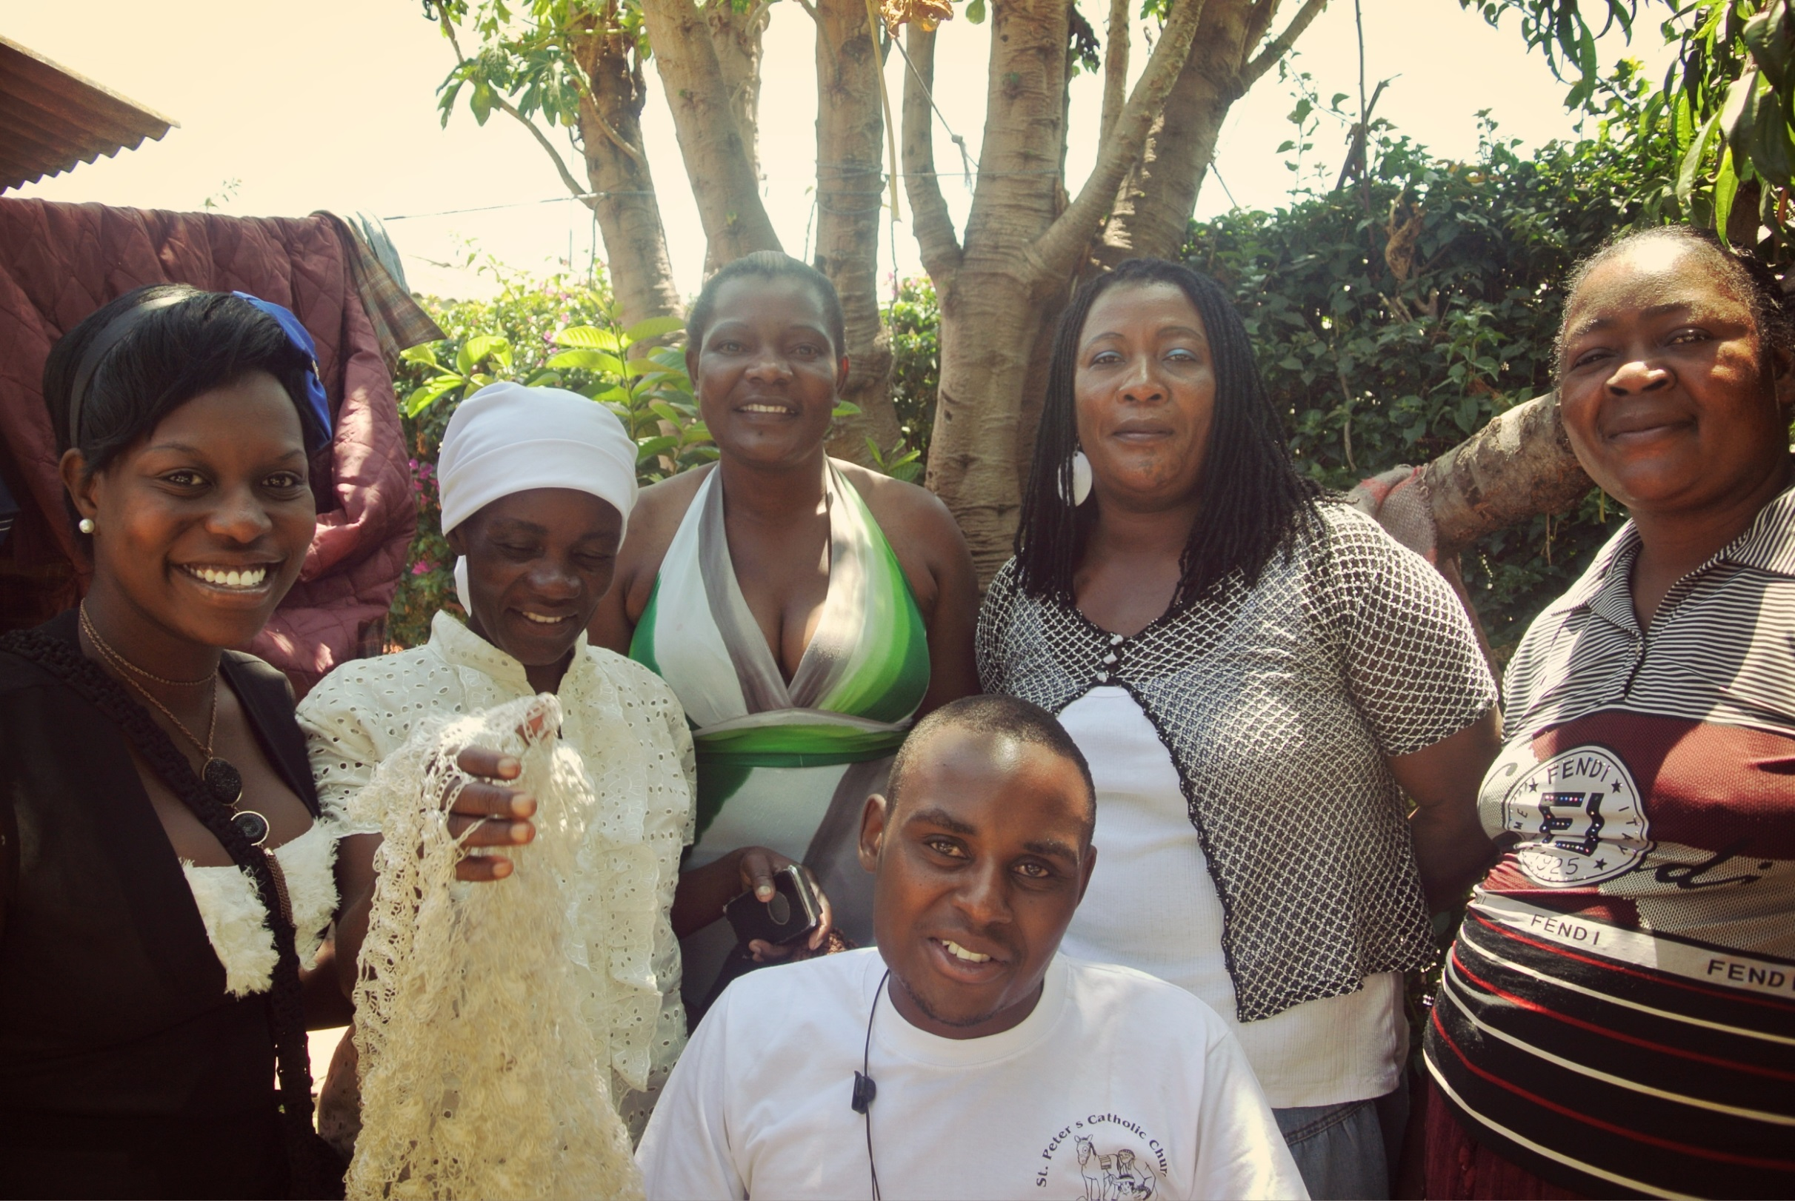

Week One: Finding God in All Things

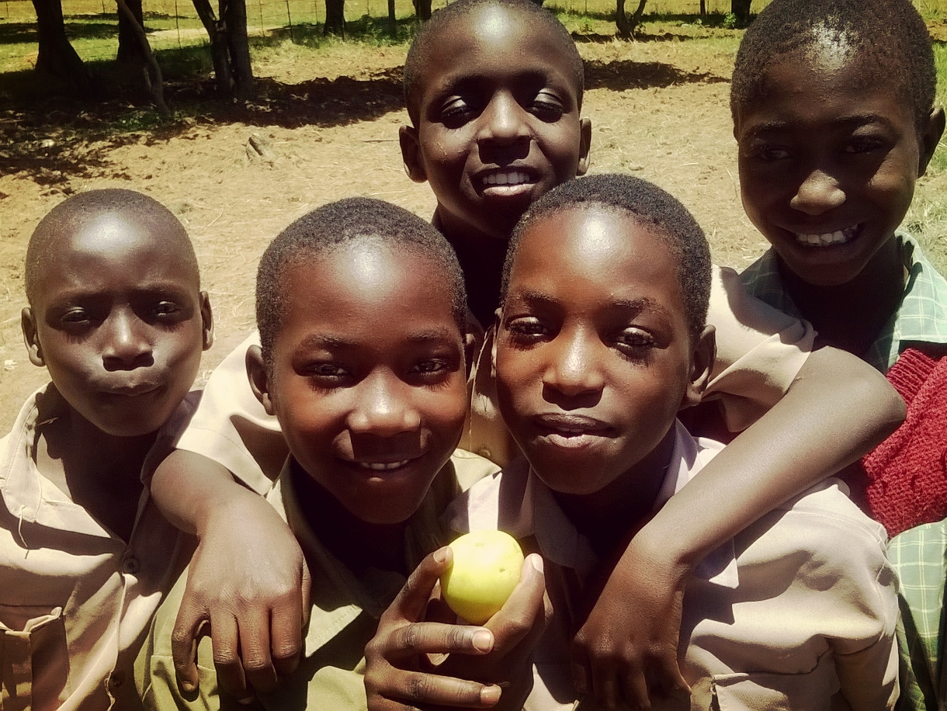

By Fr Michael Smith SJ, St. Aloysius Senior School, Glasgow

Wednesday, February 10th – The God of Peace

Scripture (cf John 14:27)
At the Last Supper, Jesus said to those sitting at table with him: “Peace I leave with you, my own peace I give. The peace I give is not the sort of peace the world can give. Do not let yourself be troubled or afraid.

Reflection
Deep down, we share a special peace with God. When Jesus said the words we've just heard, he knew that he was facing a terrible death. Somewhere deep down, the Father was with him, and despite his dreadful situation he knew deep peace. That is the kind of peace that God gives us, and in that peace God gives us we know that God is there. We thank God who brings peace to great difficulties and terrible situations. May we always bring peace wherever we go, and, as makers of peace, be true children of God.

Thursday, February 11th – Finding God in our family and friends

Scripture (cf John 15:9)
At the Last Supper, Jesus said to his disciples: “I don't call you servants, I call you friends. You are my friends. You cannot have greater love than to give your life for your friends. You are my friends, because I have told you everything I have learnt from my Father.

Reflection
Jesus had his last supper before he died surrounded by his friends. Probably some of his family were there, maybe serving the meal. It must have been a difficult time for them all, as they all realised that Jesus was in danger. Jesus seems to have felt supported by his friends, there at the meal with him. Families and friends are very important to most of us. If someone leaves our family we grieve. If a friend no longer wishes to be our friend, we are deeply hurt and upset. Good families and friends stand by each other even when things become difficult or fall apart. God is always there for us. Our relationship with God will never break up.

Friday, February 12th – God brings forgiveness

Scripture (cf John 3:16ff)
God loved the world so much that he sent his Son so that everyone who believes will be saved. And so Jesus came into the world to save everyone, not to condemn them. Everyone who believes has everlasting life.

Reflection
None of us is perfect. We may have hurt others, or been dishonest, or refused to help – but we know that God loves us and wants to bring us forgiveness. This is why He sent his Son Jesus Christ to earth, and through Jesus' life and his death on the cross we have all been saved and welcomed by God. Most of us have also been forgiven for something that we did – or didn't – do by our friends or relatives. We can find God's love in their forgiveness. We find God in forgiveness when we realise that what was wrong has been completely wiped away, just as if it had never been. It is in forgiveness that we really find God in our lives.

Monday, February 15th – Plenty and generosity

Scripture (cf Luke 16:19)
A rich man used to have a grand meal every day; but sleeping rough just by his gate was a poor man called Lazarus. The rich man would not share any of his food with Lazarus. Eventually they both died; the rich man was in hell and Lazarus in heaven.

Reflection
In the story we've just heard, the rich man enjoyed his meals, but didn't share what he had. Most of us have plenty to eat, but still sometimes find it hard to share. A priest was hearing confessions in an overseas country, and a child said he had been greedy. He looked quite thin, so the priest asked why he had been eating too much.
“Oh, I haven't been eating too much” he said, “there isn't enough to eat in our family and I had more than my fair share.” When we find God in all the good things that we have, and in the happiness of our lives, we are naturally grateful, but we also need to realise that sharing has to come as part of the deal.

Tuesday, February 16th – Finding God in the gifts God has given me

Scripture (cf Ephesians 5:16, 22ff)
You must live by the Spirit. If you do, the signs that the spirit is in us are: love, joy, peace, patience, kindness, generosity faith, gentleness and self-control. If we live by the Spirit, let us be guided by the Spirit.

Reflection
We are all talented and gifted in different ways. The gifts mentioned by St. Paul are special, though, as they are signs of the Holy Spirit, which Jesus Christ came to bring. We see these particular gifts in anyone who tries to follow Jesus Christ, and we thank God for these gifts. Because God is in us, we are wise, and joyful, patient, kind, generous, and gentle. But we all have many other gifts as well, given to us to enjoy and excel in. For a few moments, let us each think of five special gifts or talents that God has given us. [Pause for about 20 seconds]

Wednesday, February 17th – Finding God in happiness

Scripture (cf John:20ff)
Mary Magdalen went to the tomb where they had buried Jesus in the morning before it was light. She was carrying spices and other things to anoint the body of Jesus. When she arrived, she saw that the tomb was already open – and there was no body inside. She ran to tell Peter and another disciple, who came and looked inside the tomb, and then went home. Mary noticed a gardener or someone standing there, and she asked him if he knew where the body was. He said: “Mary” and she recognised Jesus at once.

Reflection
Mary and Jesus were close friends, and she was devastated when he was so cruelly killed. For a moment things seemed to get even worse when his body was taken – and then she met Jesus, alive and well. It would be hard to image the joy and happiness she felt. Let's spend a few moments in silence, and recall a place or a time where we were really happy. We'll try and remember it in detail. [pause for about 20 seconds]

Thursday, February 18th – Finding God every day

Scripture (cf Matthew 25:31-45)
The Lord separated those who were to go to heaven form those who were not. He said that those who were going to heaven had fed him when he was hungry, gave him water when he was really thirsty, gave him warm clothing, and provided him with medical care. They were surprised: 'Lord, when did we see you hungry, or thirsty, or cold or sick?' He said: 'As long as you did it to any of my people, you did it to me.'

Reflection
Some of the people we meet every day hide the face of Jesus Christ needing care and help. How do we recognize them? We can review our day each night, looking back at the places we were, what we were doing, who we met and so on. In some of these encounters we find God's love for us, and we thank God for that. In other situations, people needed to find God in their lives, needed our help and care, and maybe didn't find it – looking back over the day we can see who they were, and make sure that next time we will respond to their need. Reviewing our day like this is a sure way of finding God in everything.

Friday, February 19th – To find the Lord, we need to be generous

Scripture (cf 1Sam 3ff)
Samuel lived and served the Lord in the temple where the Ark of God was. Eli, old and fairly blind, lived there too. Samuel lay down to go to sleep, but the Lord called out: “Samuel! Samuel!” Samuel assumed it was Eli calling, and ran to help him. But Eli said: “I did not call you – go back and lie down.” The Lord called again, and Samuel went again to Eli – and this time he realised that it was the Lord who was calling. “Go back, and if the Lord calls you, say: Speak Lord, I am listening'.” And the voice did come again, and Samuel said: “Speak, Lord, your servant is listening”. And the Lord said “I am about to do great things in Israel”.

Reflection
Samuel was not able to understand that the Lord was speaking to him, until he was ready to be generous in answer to the Lord. When he said “Speak, Lord, your servant is listening” he showed that he was ready to do whatever God asked. When we try to find God in ourselves, in other people, and in the things that happen, we will only truly find him if we are ready to respond generously to what God is calling us to do. Only if we are generous in responding to God will we ever find him.

Lord Jesus, teach us to be generous, to serve you as you deserve; to give and not to count the cost, to fight and not to heed the wounds, to toil and not to seek for rest, to labour and not look for any reward, except that of knowing that we do your will.

Amen.

Week Two: Where do you stand? Called to care

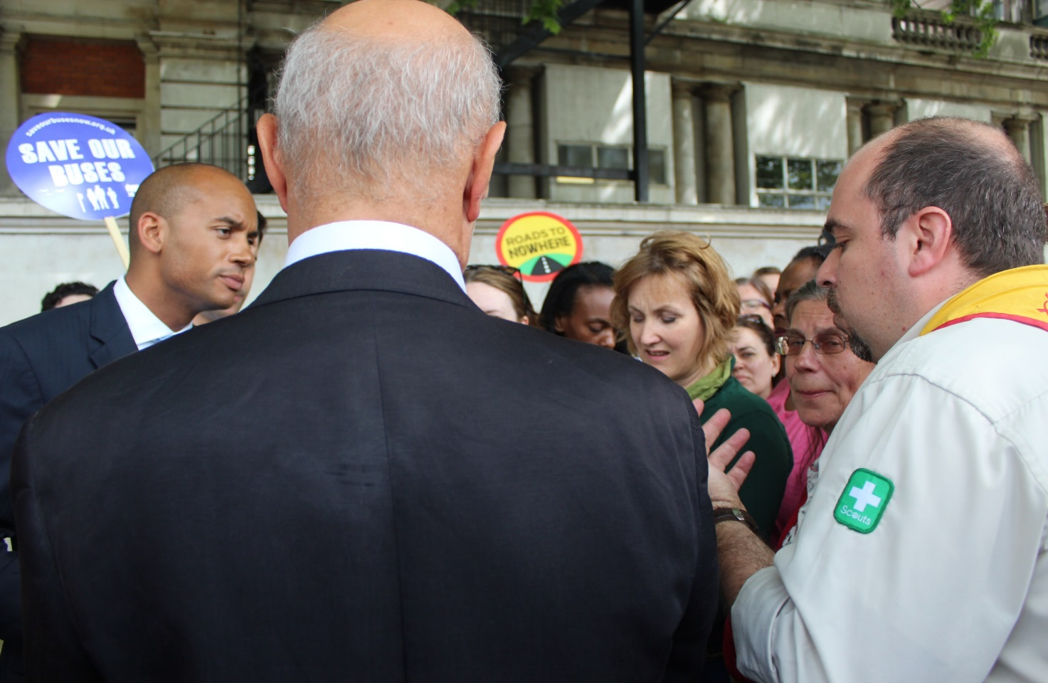

By Fr Charles Chilufya SJ, Leopard Hill High School, Zambia

Monday, February 22nd – Where do you stand with those closest to you?

Scripture (Philippians 2:4)
Let each of you look not only to his or her own interests, but also to the interests of others.

Reflection
Teilhard de Chardin, a French Jesuit scientist made this prayer: ‘Grant me to recognise in others, Lord God, the radiance of your own face.’ The people around us are a great gift even though at times we fail to recognise it. St. Ignatius teaches us to look for God within us, around us and in other people. For a few moments, let us remain still and thank God for the gift of our teachers, our classmates and all those who serve in our school. When you are in school today, try to recognize God’s face in the people you meet, especially those closest to you. Can you also see the face of God in the kitchen staff, the cleaners and all those who work behind the scenes to look after you?

Tuesday, February 23rd– Where do you stand with yourself?
Scripture (cf Isaiah 43:1-2, 4)
This is what the Lord says – he who created you, he who formed you: "Do not fear, for I have redeemed you; I have called you by name; you are mine. When you pass through the waters, I will be with you; and when you pass through the rivers, they will not sweep over you. When you walk through the fire, you will not be burned; the flames will not set you ablaze. Since you are precious and honoured in my sight, and because I love you, I will give people in exchange for you, nations in exchange for your life.

Reflection
For each one of us to share real love with others, we first have to experience God’s love. This love has already been poured out upon us, but sometimes we are not aware of it. St. Ignatius challenges us to be aware of the love of God at work in nature, in others and in ourselves. Take time to think about everything that lives, from the air passing through your lungs to the natural world that surrounds you. God constantly calls you into being in each and every moment. All we are and all we have is God’s gift to us.

Wednesday, February 24th – Where do you stand within humanity?

Scripture (cf 1 John 1:1-3)
We declare to you what was from the beginning, what we have heard, what we have seen with our eyes, what we have looked at and touched with our hands, concerning the word of life. We declare to you what we have seen and heard so that you also may have fellowship with us; and truly our fellowship is with the Father and with his Son Jesus Christ.

Reflection
Before Jesus was born, the Father, the Son and the Holy Spirit looked upon the earth with compassion. The Holy Trinity felt moved to save humanity. So they decided to send the Son, Jesus the word of life. Imagine looking at the whole of the earth and catch a glimpse of what is happening in other nations. In some nations there is peace, prosperity and development but in others there is war, misery and poverty. God sends his living word, Jesus, to show us a new way to live, to show us how to care about other human beings, wherever on earth they are.

Thursday, February 25th- Where do you stand in your decisions?

Scripture (Psalm 25:4-6).
Show me your ways, O Lord, teach me your paths; guide me in your truth and teach me, for you are God my Saviour, and my hope is in you all day long. Remember, O Lord, your great mercy and love, for they are from of old.

Reflection
Good decision-making is important because who I become is determined by what I choose. However the decisions we make affect other people. We are not islands separated by the seas. During the time of the financial crisis we heard how the decisions of a few people affected the whole world; a few people made decisions as if others did not matter. We learn to make good decisions when we learn to find space for silence and prayer; when we reflect on our lives; when we learn from the wisdom of the Scriptures as well as the wisdom of our culture and of others.

Friday, February 26th – Where do you stand within creation?

Scripture (cf Romans 8:18-19)
I consider that the sufferings of this present time are not worth comparing with the glory about to be revealed to us. For creation waits with eager longing for the children of God to be revealed.

Reflection
An Indian proverb says that ‘we have borrowed the earth from our future generations.’ Sometimes we can treat the natural world as if it belongs to us. In fact, God wants us to take care of it for future generations. In thirteenth century Italy, Saint Francis wrote these words to praise the God of creation in a song called the Canticle of the Sun:

Be praised, my Lord, through all Your creatures,
Especially through my lord Brother Sun,
Who brings the day; and You give light through him.
And he is beautiful and radiant in all his splendour!
Of You, Most High, he bears the likeness.
Be praised, my Lord, through Sister Moon and the stars;
In the heavens You have made them bright, precious and beautiful.
Be praised, my Lord, through Brothers Wind and Air,
And clouds and storms, and all the weather,
Through which You give Your creatures sustenance.
Be praised, my Lord, through Sister Water;
She is very useful, and humble, and precious, and pure.
Be praised, my Lord, through Brother Fire,
Through whom You brighten the night.
He is beautiful and cheerful, and powerful and strong.
Be praised, my Lord, through our sister Mother Earth,
Who feeds us and rules us,
And produces various fruits with coloured flowers and herbs.
Be praised, my Lord, through those who forgive for love of You;
Through those who endure sickness and trial.
Week Three:
The Passion and Death of Jesus – Encountering Injustice
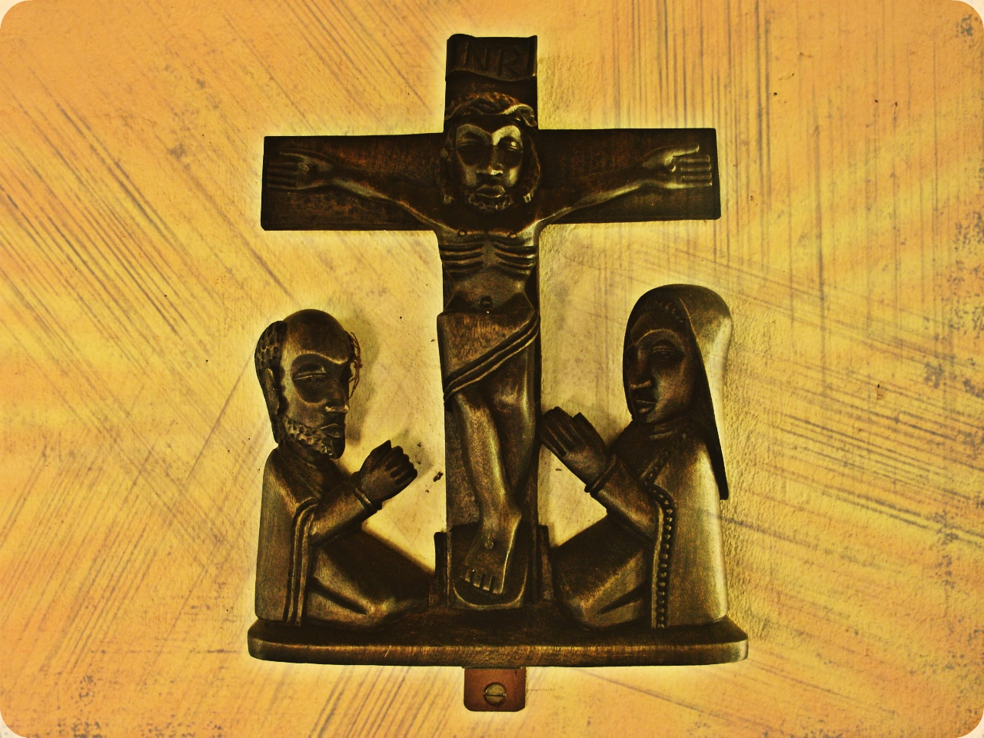
By James Potter, Wimbledon College, Wimbledon

Monday, February 29th – How will you respond?

Scripture (John 13:12-15)
After Jesus had washed his disciples' feet and had put his outer garment back on, he sat down again. Then he said: ‘Do you understand what I have done? You call me your teacher and Lord, and you should, because that is who I am. And if your Lord and teacher has washed your feet, you should do the same for each other. I have set the example, and you should do for each other exactly what I have done for you.’

Reflection
How incredible is it that Jesus, on the night he knows he will be betrayed, arrested, and abandoned by his friends, does not shun his disciples for their failings, but chooses to perform an act of pure generosity, and washes their feet? Martin Luther King, who campaigned for the rights of all people said that ‘Darkness cannot drive out darkness: only light can do that. Hate cannot drive out hate: only love can do that.’ Like Jesus, we will come across situations of injustice, where people are treated unfairly, where innocent people are harmed and mistreated. How will we react? Will we respond like Jesus with hope, compassion, generosity, with love?

Tuesday, March 1st – A new commandment

Scripture (cf John 13:33-38)
Jesus said “I am giving you a new command. You must love each other, just as I have loved you. If you love each other, everyone will know that you are my disciples.” Simon Peter asked, “Lord, where are you going?” Jesus answered, “You can’t go with me now, but later on you will.” Peter asked, “Lord, why can’t I go with you now? I would die for you!” “Would you really die for me?” Jesus asked. “I tell you for certain that before a rooster crows, you will say three times that you don’t even know me.”

Reflection
Saying you will do something is easy, but taking action is a whole other ball game. Peter realizes this on the evening Jesus is arrested. He is passionate about Jesus and claims he will die for him. Jesus has sparked a flame deep inside him, and yet when it comes to living out his words, Peter is weak, and does not stay with Jesus. God never writes anyone off, no matter what they have done. Later, Peter will recognise his failings and become the one chosen to lead the Church.
Ann Frank, a Jewish girl who died in a Nazi concentration camp during the Second World War wrote: ‘How wonderful it is that nobody need wait a single moment before starting to improve the world.’ Do you have the same strength to start to change the world today?

Wednesday, March 2nd – How much love?

Scripture (John 18:3-6; 10-12)
Judas had promised to betray Jesus. So he went to the garden with some Roman soldiers and temple police, who had been sent by the chief priests and the Pharisees. They carried torches, lanterns, and weapons. Jesus already knew everything that was going to happen, but he asked, “Who are you looking for?” They answered, “We are looking for Jesus from Nazareth!” Jesus told them, “I am Jesus!” At once they all backed away and fell to the ground.[…] Simon Peter had brought along a sword. He now pulled it out and struck at the servant of the high priest. The servant’s name was Malchus, and Peter cut off his right ear. Jesus told Peter, “Put your sword away. I must drink from the cup that the Father has given me.” The Roman officer and his men, together with the temple police, arrested Jesus and tied him up.

Reflection
When you see someone being bullied, how do you react? When you see a story of people suffering working in terrible conditions in a foreign country, how do you react? When you see people dying because of poverty, lack of access to healthcare, lack of basic necessities like food, water, sanitation, how do you react? We choose how we react to these situations. Peter chooses to respond with violence but Jesus shows us a different way. He asks for peace to stop the cycle of unending violence.

‘It is not the magnitude of our actions
But the amount of love
That is put into them that matters.’

(Mother Theresa)

Thursday, March 3rd – The first step is yours

Reading (cf John 19:5-12; 16)
Jesus came out, wearing the crown of thorns and the purple robe. Pilate said, “Here is the man!” When the chief priests and the temple police saw him, they yelled, “Nail him to a cross! Nail him to a cross!” Pilate told them, “You take him and nail him to a cross! I don’t find him guilty of anything.” The crowd replied, “He claimed to be the Son of God! Our Jewish Law says that he must be put to death.” When Pilate heard this, he was terrified. Pilate wanted to set Jesus free but he handed Jesus over to be nailed to a cross.

Reflection
Pilate is aware that the crucifixion of Jesus is unjust. He can see that Jesus is innocent and that he does not in any way deserve to be put to death. We also often see injustice in in our lives, against people or the planet. People can be abused because of their race, interests, culture, abilities, social status, looks, and many other reasons. Pilate reacts to injustice with fear. He knows what is going on is wrong, but he is too weak to stand up for what is right. Similar struggles can happen within us. Turning a blind eye to injustice, or failing to summon up the perseverance, enthusiasm and courage to fight against it, can be easy and attractive options.

‘Take the first step in faith.
You don't have to see the whole staircase,
Just take the first step.’

(Martin Luther King Jr.)

Friday, March 4th – Jesus’ strength

Scripture (cf John 19:17-19;25-30)
Jesus was taken away, and he carried his cross to a place known as “The Skull.” In Aramaic this place is called “Golgotha”. There Jesus was nailed to the cross. When Jesus saw his mother and his favourite disciple with her, he said to his mother, “This man is now your son.” Then he said to the disciple, “She is now your mother.” From then on, that disciple took her into his own home. Jesus knew that he had now finished his work. And in order to make the Scriptures come true, he said, “I am thirsty!”. A jar of cheap wine was there. Someone then soaked a sponge with the wine and held it up to Jesus' mouth on the stem of a hyssop plant. After Jesus drank the wine, he said, “Everything is done!” He bowed his head and died.

Reflection
Jesus was God among us. Jesus showed us what being truly human was like, what it was to truly love. Loving means living for others and never holding back, even in the most difficult circumstances. Jesus never got to the point of saying, “You know what? You lot are not worth it!” He never let the inhumanity of others change the message of love and peace he came to share. When we are faced with injustice and we feel weak and helpless, let us look to Jesus Christ, and ask him not to let problems hold us back from being generous, kind and loving. Let us pause for a moment and allow our hearts to be moved by the strength that Jesus showed when he gave the world the ultimate gift of his life.

‘Christ did not do away with suffering.
He did not even wish to unveil
To us entirely the mystery of suffering.
He took suffering upon Himself.’

(Pope Paul VI)

Week Four: Resurrection and Hope
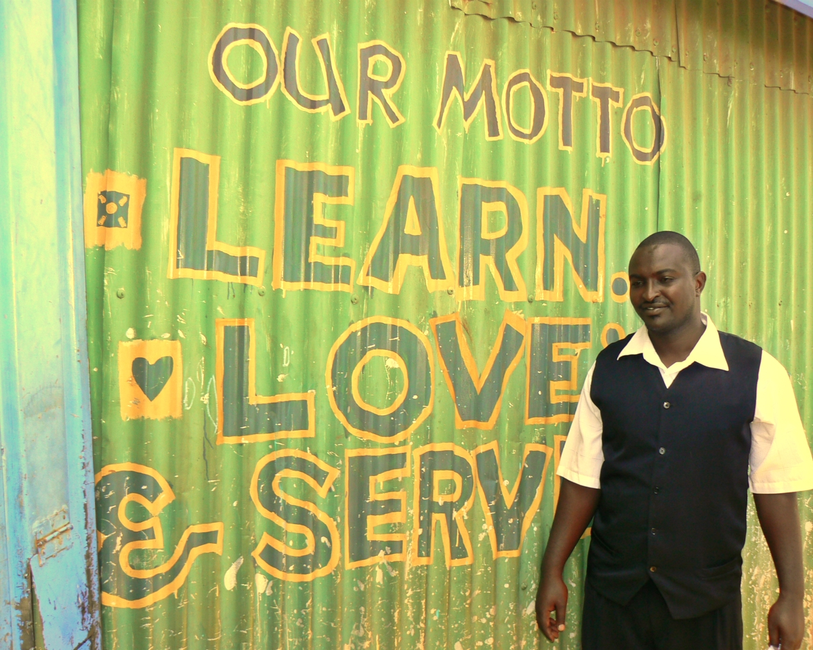

By Sarah Young, Stonyhurst College, Clitheroe

Monday, March 7th – Hearts of stone?

Scripture (Mark 15: 46)
Then Joseph bought a linen cloth, and taking down the body, wrapped it in the linen cloth, and laid it in a tomb that had been hewn out of the rock. He then rolled a stone against the door of the tomb.

Reflection

Lord Jesus, there are times when I feel hurt and angry.
It seems impossible to forgive. My heart remains hard as stone.
It is like the stone blocking out all the light inside the tomb and
Blocking the way to new life.

Be with me in such moments, Lord.
Melt my heart of stone.
Help me to see another point of view.
Help me to see a way to peace when all I can see are obstacles in my path.

Amen.

Tuesday, March 8th – Awaken your deepest desires

Scripture (Luke 23: 53-54)
Then he took it down, wrapped it in a linen cloth, and laid it in a rock-hewn tomb where no one had ever been laid. It was the day of Preparation, and the Sabbath was beginning.

Reflection

Lord Jesus, light is beginning to dawn.
The tomb in which they laid you had never before held a body.
It does not know the rules of death.
The rising sun fills the corners of the roughly hewn tomb with light.
The hard, immovable stone has shifted.
Let it be the same with me, Lord.
Let your light reach the darkest parts of me;
May death give way to life.
Let me dare to believe that light will dawn, obstacles will be overcome,
hurt and pain will no longer hold their power.
Let me believe that nothing is impossible with you by my side.

Amen.

Wednesday, March 9th – Known and loved

Scripture (John 20: 16)
Jesus said to her, “Mary!” She turned and said to him in Hebrew, “Rabbouni!” (which means Teacher).
Reflection

Lord Jesus, there are so many people in the world, even just in my school,
Whose names I do not know.
How could I know all of them, Lord? It’s impossible!
Yet, you know each one by name. You called each one into being.

Even if I cannot know their names, help me to recognise you in each person that I might meet. If I can only look into their eyes and greet them with the warmth you greeted Mary and the disciples on the day of your resurrection, then maybe they will feel known and loved today.

Amen.

Thursday, March 10th – Who are you now?

Scripture (John 21: 12-14)
Jesus said to them, “Come and have breakfast.” Now none of the disciples dared to ask him, “Who are you?” because they knew it was the Lord. Jesus came and took the bread and gave it to them, and did the same with the fish. This was now the third time that Jesus appeared to the disciples after he was raised from the dead.

Reflection

Lord Jesus, you always make the first move.
You loved me first even before I was aware of you.
You are there waiting and ready for me to come to you.

Lord, with you I could do so much.
I see people in need and I don’t know what to do to help.
I don’t know where to start. I can’t do it all by myself.
When I feel helpless in the face of poverty and injustice,
Let me know that you are already there.
All I need to do is to go and join you
And get to work alongside you.
Maybe then, others will join in too.

Amen.

Friday, March 11th – More than you can ask or imagine

Scripture (cf Ephesians 3: 18-21)
I pray that you may have the power to understand, with all the saints, the breadth and length and height and depth, and to know the love of Christ that goes beyond all knowledge, so that you may be filled with all the fullness of God. Now to him who by the power at work within us is able to accomplish far more than all we can ask or imagine, to him be glory in the church and in Christ Jesus to all generations, forever and ever. Amen.

Reflection

Lord Jesus, my heart is full.
For my sake, you died on the cross and rose again to new life.
You have shown me that your plans are for peace and not disaster
For me, for those close to me, for all the peoples of the world and
For the whole of your creation.
This is the time for great hope.

I feel so grateful for all that you have done for me,
For the new life you bring to those in need.
I know that you can transform the ugliness of pain into something beautiful.
I only have to be attentive to the beauty of creation to know that, with you, All things are possible.

Amen.

